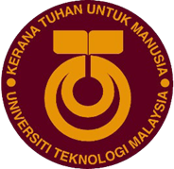

UNIVERSITI TEKNOLOGI MALAYSIA

81310, JOHOR BAHRU, JOHOR, MALAYSIA

SECP1513 (TECHNOLOGY AND INFORMATION SYSTEM)

SESSION 2023/2024

SECTION 07

PC Assemble (Lab)

GROUP 7: INNOVATORS

|  |  |
| --- | --- |
| **NAME** | **MATRIC NUMBER** |
| SITI NURUL AMIRAH BINTI SHEIKH SULAIMAN | A23CS0182 |
| NGEOW ZHI YU | A23CS0255 |
| KHOO ZI LING | A23CS0231 |
| NUR FARHANAH HUSNI BINTI NOR FAIZAL | A23CS0155 |
| ERIKA BINTI HAWAPI | A23CS0076 |
| **LECTURER NAME:** TS. DR. SARINA BINTI SULAIMAN | |

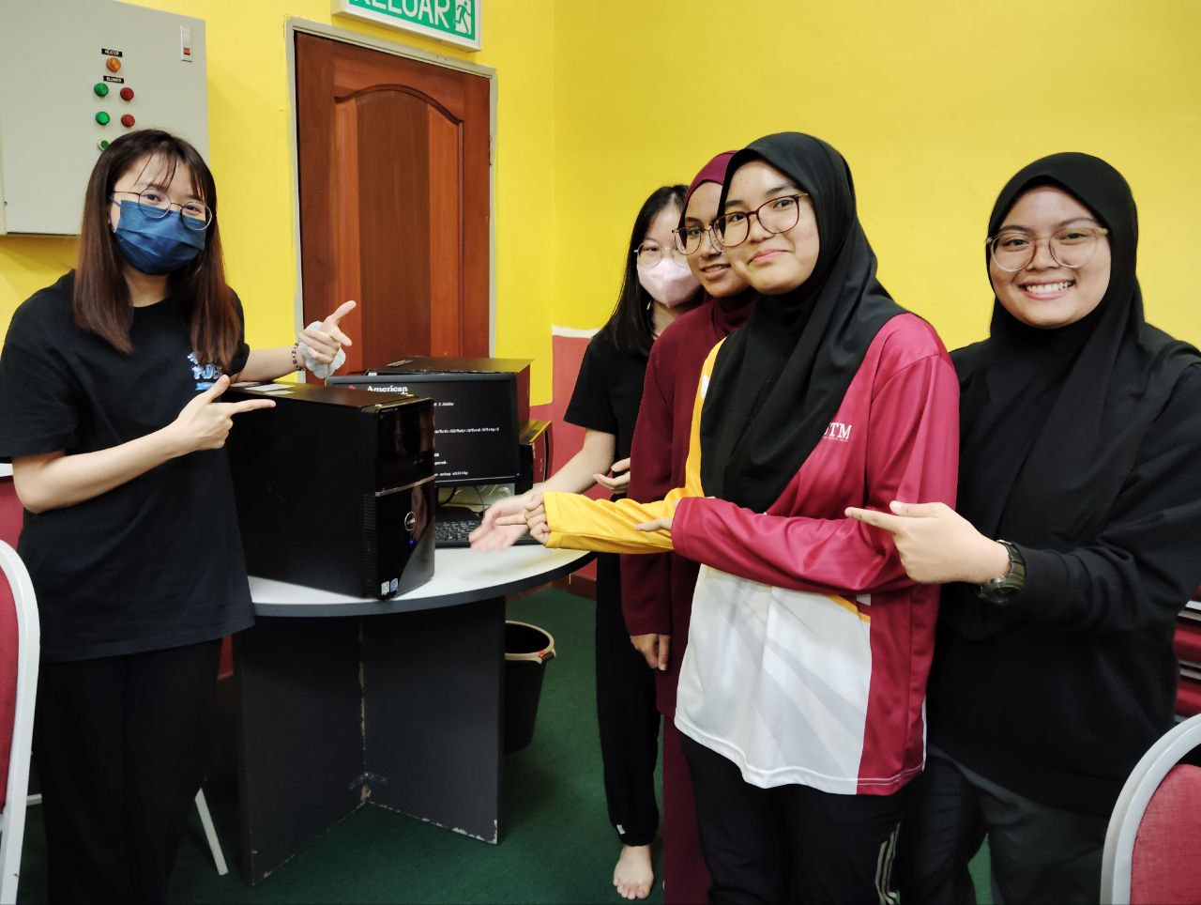

In the PC lab, I embarked on a comprehensive journey to unravel the intricacies of computer assembly. The lesson began with fundamental steps, such as delicately opening the CPU case, unveiling the intricate dance of connecting motherboard, RAM, storage drives, and more. Each step felt like adding pieces to a puzzle that would soon come to life. As I navigated the labyrinth of cables and components, the once-intimidating task of setting up a computer transformed into a methodical process that unveiled the harmony within the machine's architecture.

Amid the nuts and bolts of hardware assembly, a profound reflection on knowledge and group collaboration emerged. Beyond mastering the technical intricacies, the lab underscored the importance of working collaboratively within a group setting. Assembling a computer became a collective effort, where each team member contributed unique skills and insights. Collaborative problem-solving became a cornerstone, as we navigated challenges and celebrated victories together. This collaborative spirit extended beyond the hardware assembly process, involving the sharing of knowledge, troubleshooting issues, and leveraging diverse skill sets to achieve a common goal. The lab not only fortified technical skills but also honed the ability to work effectively within a team, a skill that transcends the realm of PC assembly.

In the end, the culmination of this immersive experience was not just a successfully built PC but a symbolic representation of a journey of knowledge acquisition and collaborative growth. The hum of the fans and the glow of LEDs as the computer powered up served as a testament to the fusion of technical proficiency and collaborative prowess cultivated in the PC lab. The lesson learned extended beyond the nuts and bolts of computer assembly, encompassing a holistic understanding of the collaborative nature inherent in both knowledge acquisition and real-world problem-solving.

